**Hands-on 1: Cognos Connections**

1. Created a new folder named ‘DG’ in ‘Team content’.
2. Copied 2 reports namely, ‘Sales growth year over year’ and ‘Sales summary’ from ‘Team content>Sample>Reports>Standard reports’ folder.
3. Renamed the reports by going to properties of both the copied reports from ‘Sales growth year over year’ to ‘Sales growth yearly DG’ and ‘Sales summary’ to ‘Sales summary DG’.
4. Scheduled the report to run in secure PDF format for every 2 hours from 8AM to 10PM on 2-OCT-2020 using password “abcd1234” from schedule tab using daily schedule and can be seen in below screenshots.

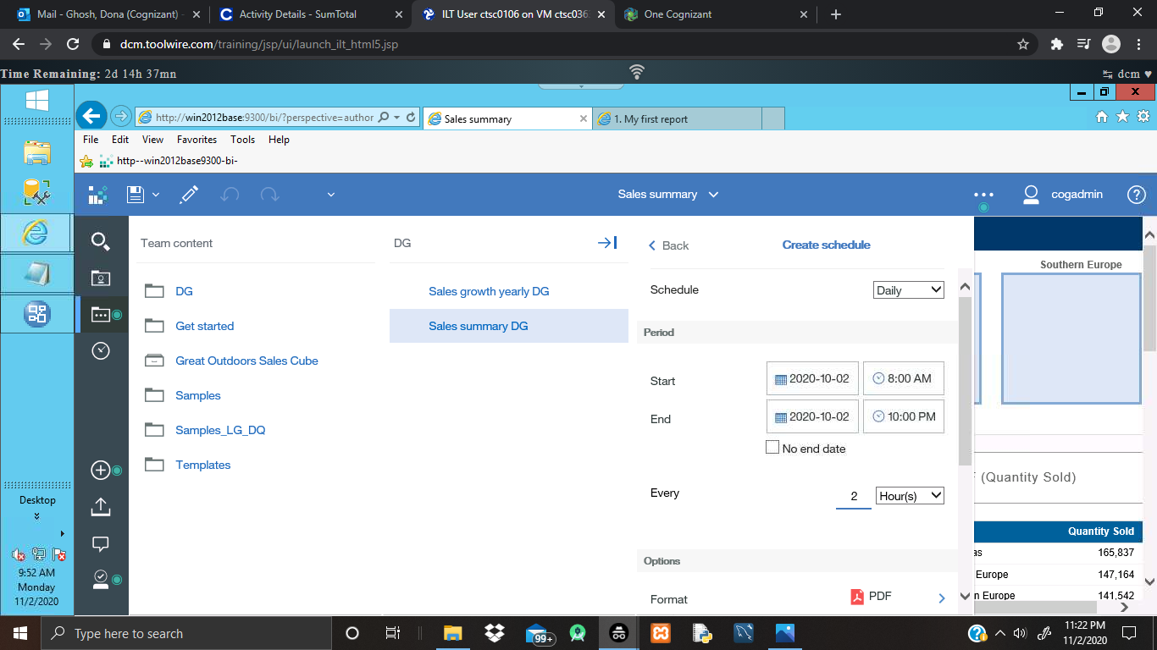

Screenshot for scheduling the report to run for every two hours from 8AM to 10PM on 2-OCT-2020 in PDF format

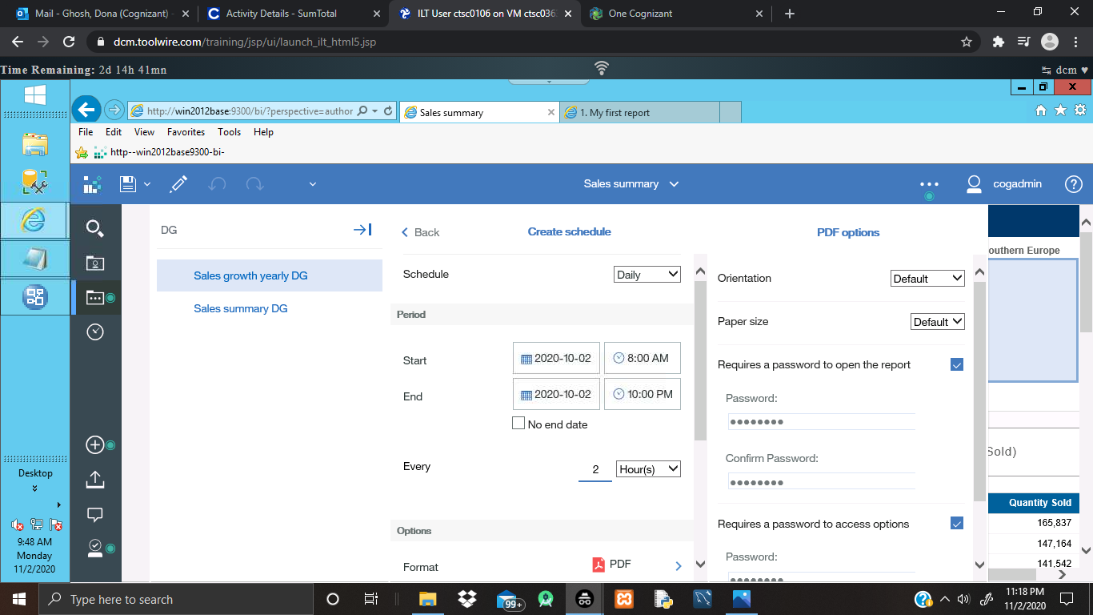

Screenshot for scheduling the report in secure PDF format

1. In ‘Manage’ tab, created data server connection using Microsoft SQL Server connection using ‘Connection name’: ‘GoSales’, ‘server’: ‘win2012base’, ‘port name’: ‘1433’, ‘database name’: ‘gosales’ and using SQL credentials as provided, tested and saved.

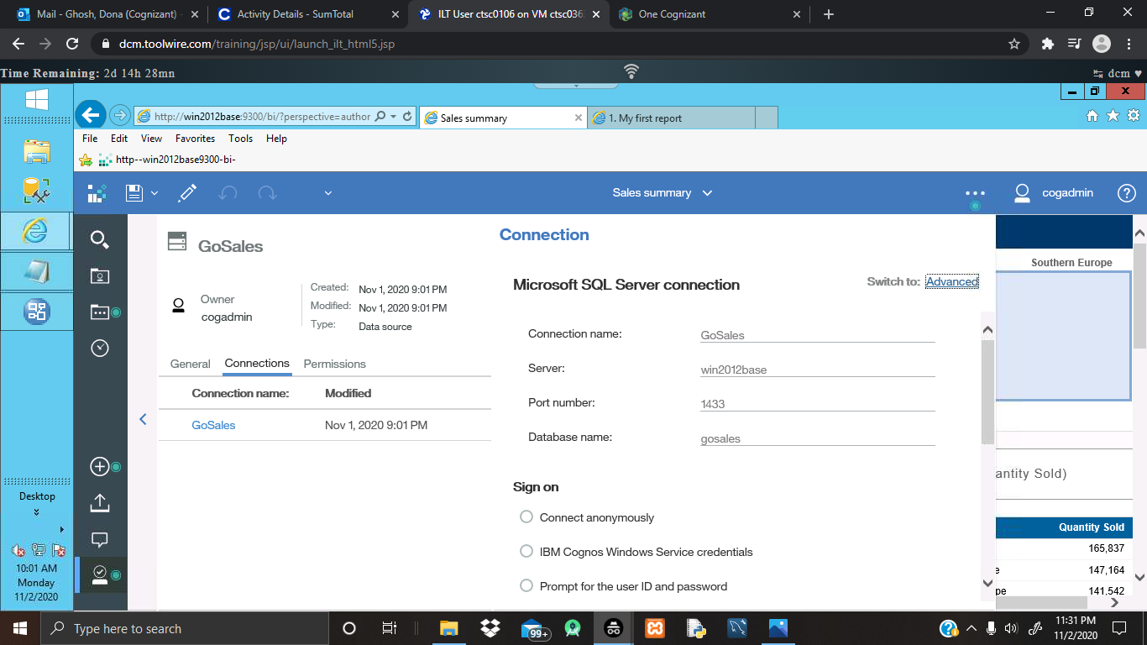

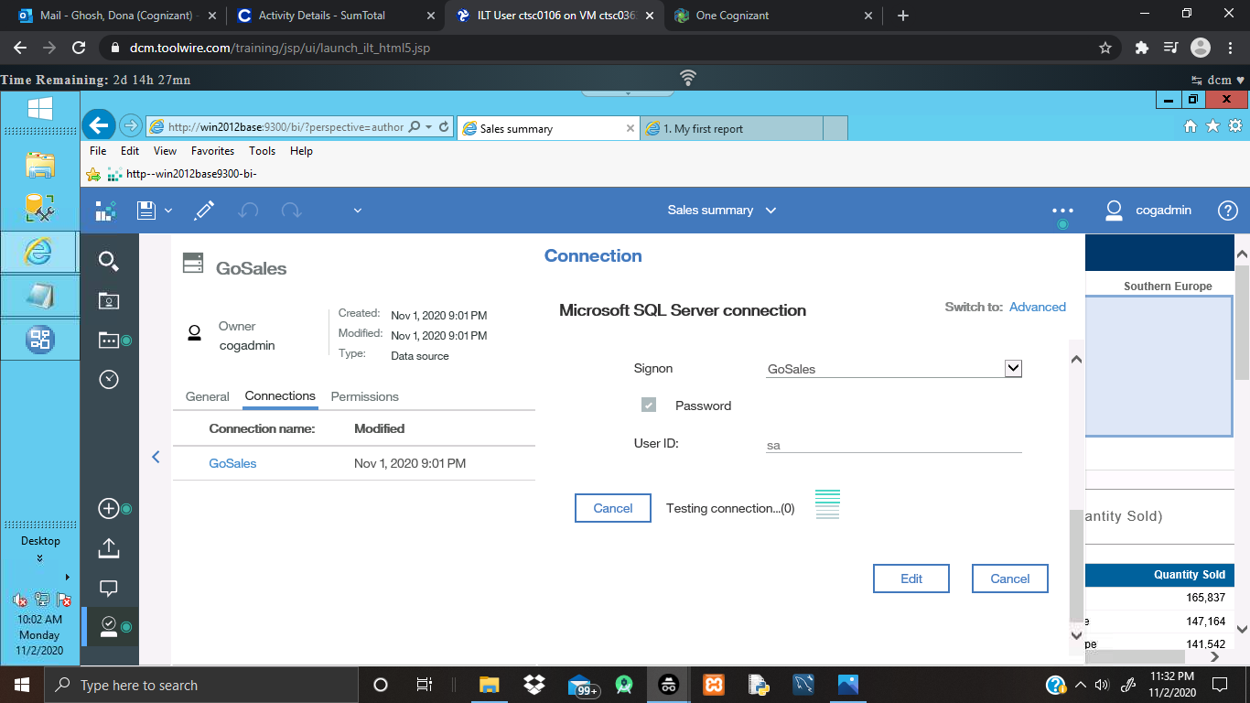

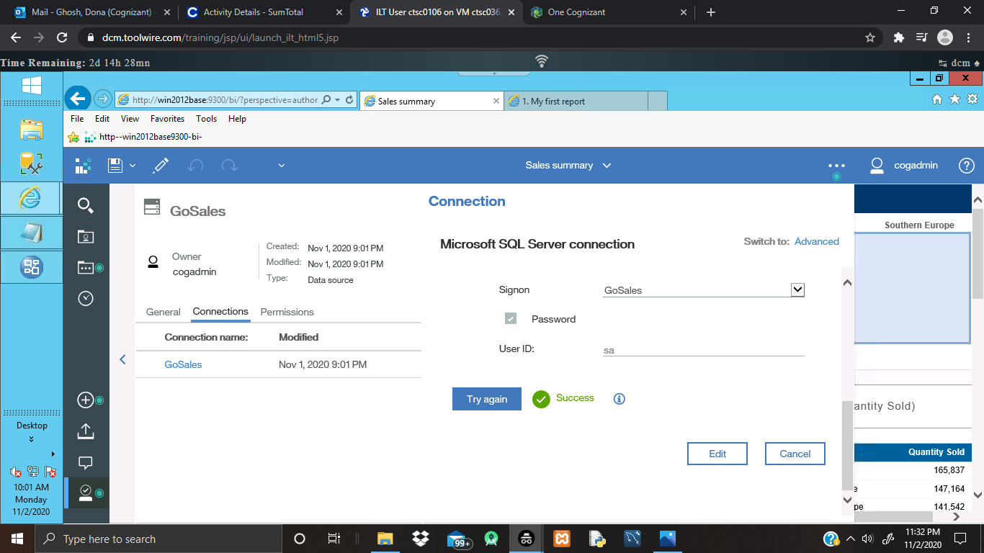

Screenshots for creation of New Data Server Connection, tested and saved